Assignment 3 Triggers, Stored Procedures and Views

Total points: 50

This assignment should be completed individually. For each problem, submit your SQL statement and a screen shot of the SQL results in a single Word document or pdf file. Submit the file via eLearning.

I recommend creating a new user and workspace named after your netid, log in as that user and load the database script (provided in this week's assignment folder). Before you attempt to write any SQL queries, familiarize yourself with the database structure and data. I have provided a relational diagram and sample data for this database.
Write queries to address each of the problems below. Submit both the SQL statements and the screen prints of the outputs from Oracle. (2 points for the screen shots). Be sure the workspace name is included in your screen shots or if you are using Oracle Live, make sure your user name is included in the ouput.
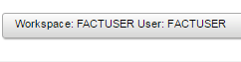
OurVideo is a small movie rental company with a single store. OurVideo needs a database system to track the rental of movies to its members. OurVideo can own several copies (VIDEO) of each movie (MOVIE). For example, the store may have 10 copies of the movie “Twist in the Wind”. “Twist in the Wind” would be one MOVIE and each copy would be a VIDEO. A rental transaction (RENTAL) involves one or more videos being rented to a member (MEMBERSHIP). A video can be rented many times over its lifetime, therefore, there is a M:N relationship between RENTAL and VIDEO. DETAILRENTAL is the bridge table to resolve this relationship. The complete ERD is provided in the Figure below.
OurVideo ERD
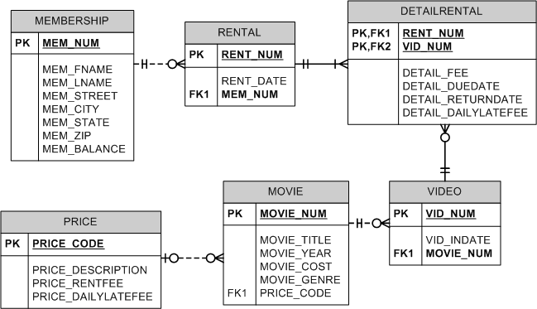

- Alter the VIDEO table to include an attribute named VID_STATUS to store character data up to 4 characters long. The attribute should not accept null values. The attribute should have a constraint to enforce the domain (“IN”, “OUT”, and “LOST”), and have a default value of “IN”. (5pts) You will use an ALTER TABLE statement to add a new column. That new column will have a constraint on it.

alter table video
add (vid_status varchar2(4) default 'IN' not null, constraint constraint_vid_status_check check(vid_status in ('IN', 'OUT', 'LOST')))
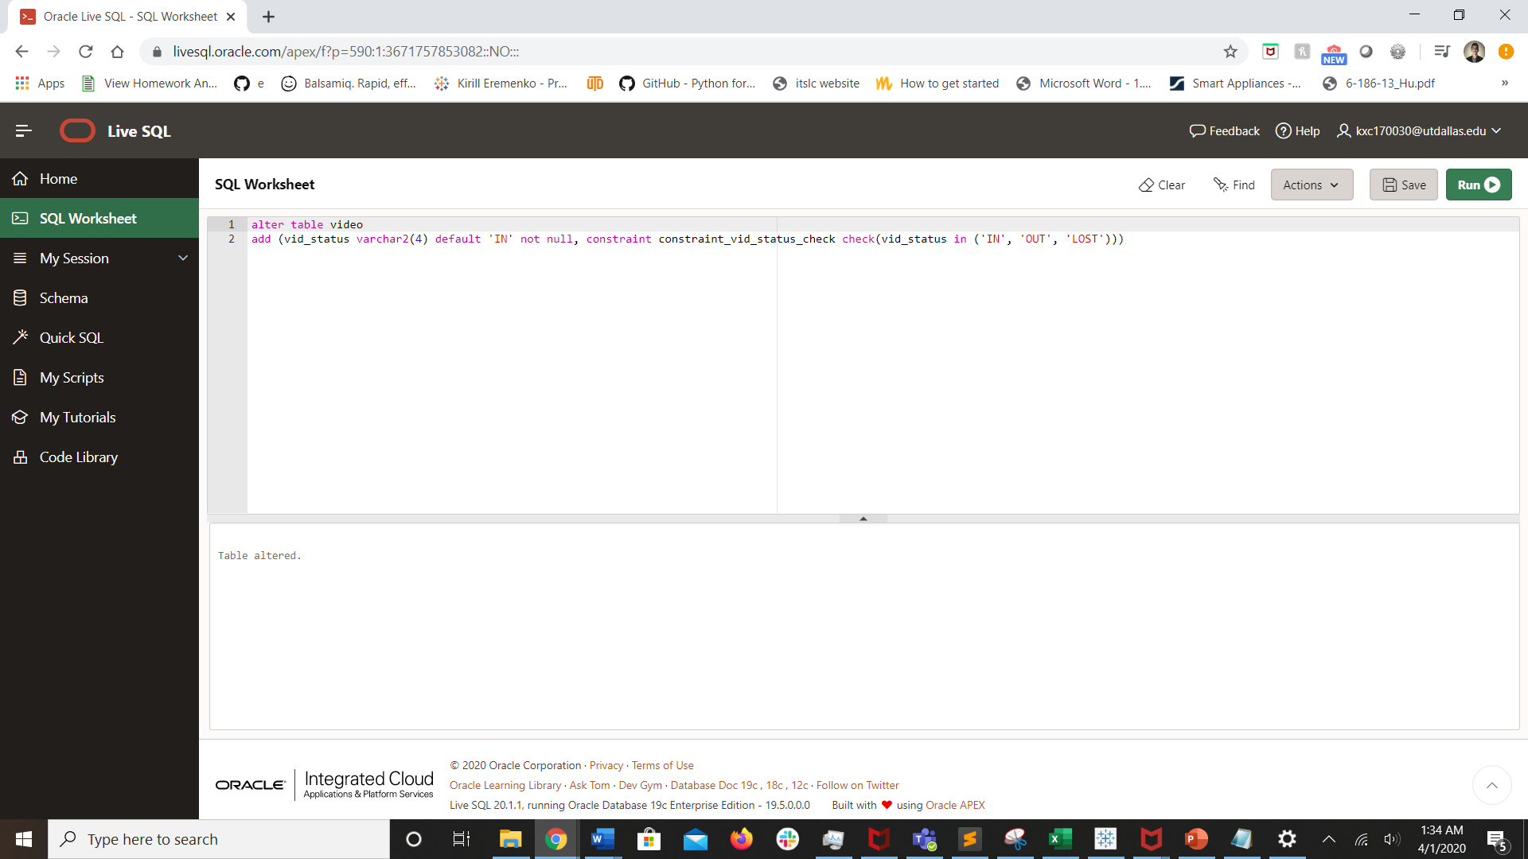

- Create a trigger named trg_videorental_up that will update the correct value VID_STATUS in the VIDEO table whenever a video is checked out (OUT) or returned (IN). The trigger should execute as an AFTER trigger when the DETAIL_RETURNDATE attribute is updated in the DETAILRENTAL table. The trigger should satisfy the following conditions:

  - If he DETAIL_RETURNDATE in the detail rental table is set to NULL, the VID_STATUS should be set to “OUT”.
  - If the DETAIL_RETURNDATE in the detail rental table is set to > than the current date, the VID_STATUS should be set to “OUT”.
  - If the DETAIL_RETURNDATE in the detail rental table is set to < or = to the current date, the VID_STATUS should be set to “IN”.
  - If the DETAIL_RETURNDATE in the detail rental table is set to “01/01/01”, the VID_STATUS should be set to “LOST”.

create or replace trigger trg_videorental_up
after update of detail_returndate on detailrental
for each row
begin
if :new.detail_returndate = null then
update video v
set v.vid_status = 'OUT'
where v.vid_num = :new.vid_num;
elsif :new.detail_returndate > sysdate then
update video v
set v.vid_status = 'OUT'
where v.vid_num = :new.vid_num;
elsif :new.detail_returndate = '01-01-01' then
update video v
set v.vid_status = 'LOST'
where v.vid_num = :new.vid_num;
elsif :new.detail_returndate <= sysdate then
update video v
set v.vid_status = 'IN'
where v.vid_num = :new.vid_num;
end if;
end;

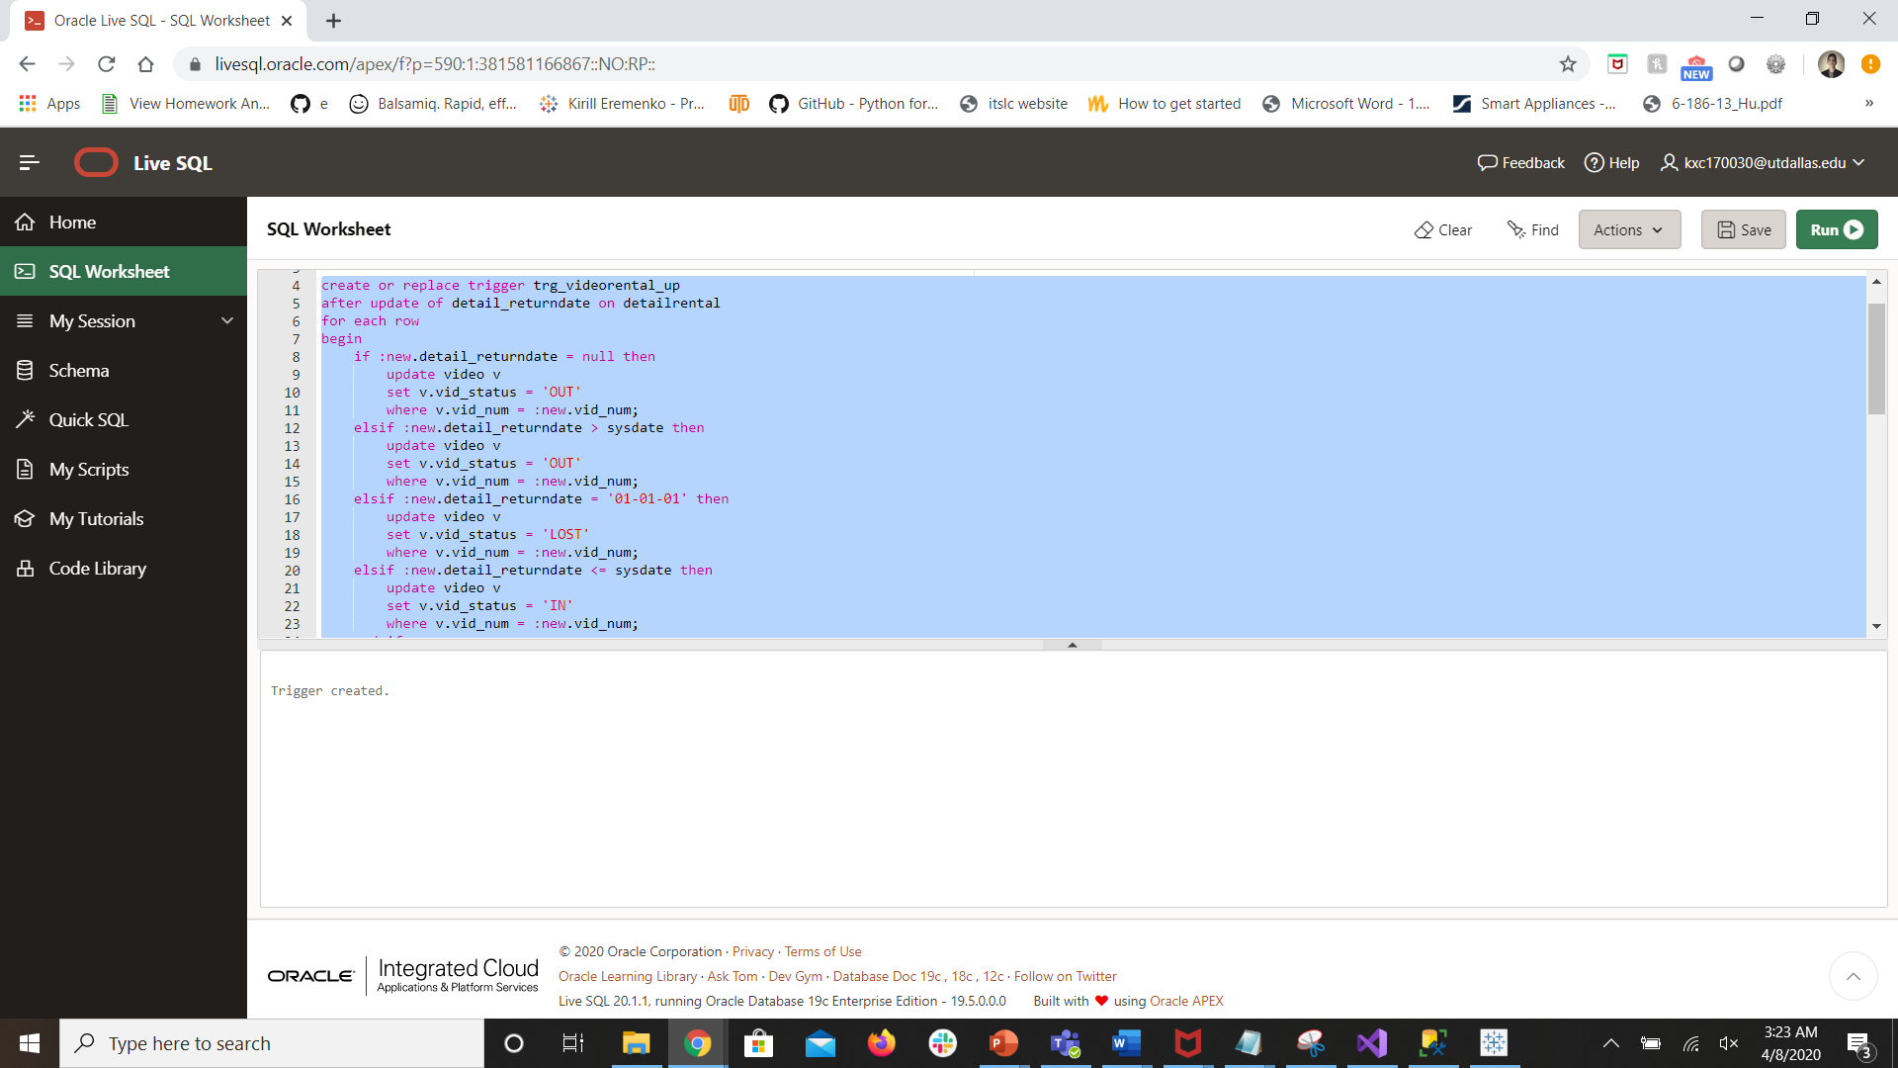
--After you have created the trigger, test the trigger. Insert or Update a record for each scenario in the detail rental table. Show the insert and update statements. When checking out a video, a new row is insert into the rental and detailrental tables. When checking in a video the return date is updated. When a video is lost the returndate is set to 01/01/01. You should have the following:

- To test the first condition - An insert statement to insert a new row into the rental and detail_rental table. Use Member_id 113 and video_id 34366. Show the new record.

insert into rental
values(1010, '03-03-20', 113);

insert into detailrental
values(1010, 34366, 2, '03-05-20', '03-07-20', 1);

select * from rental
where rent_num = 1010;

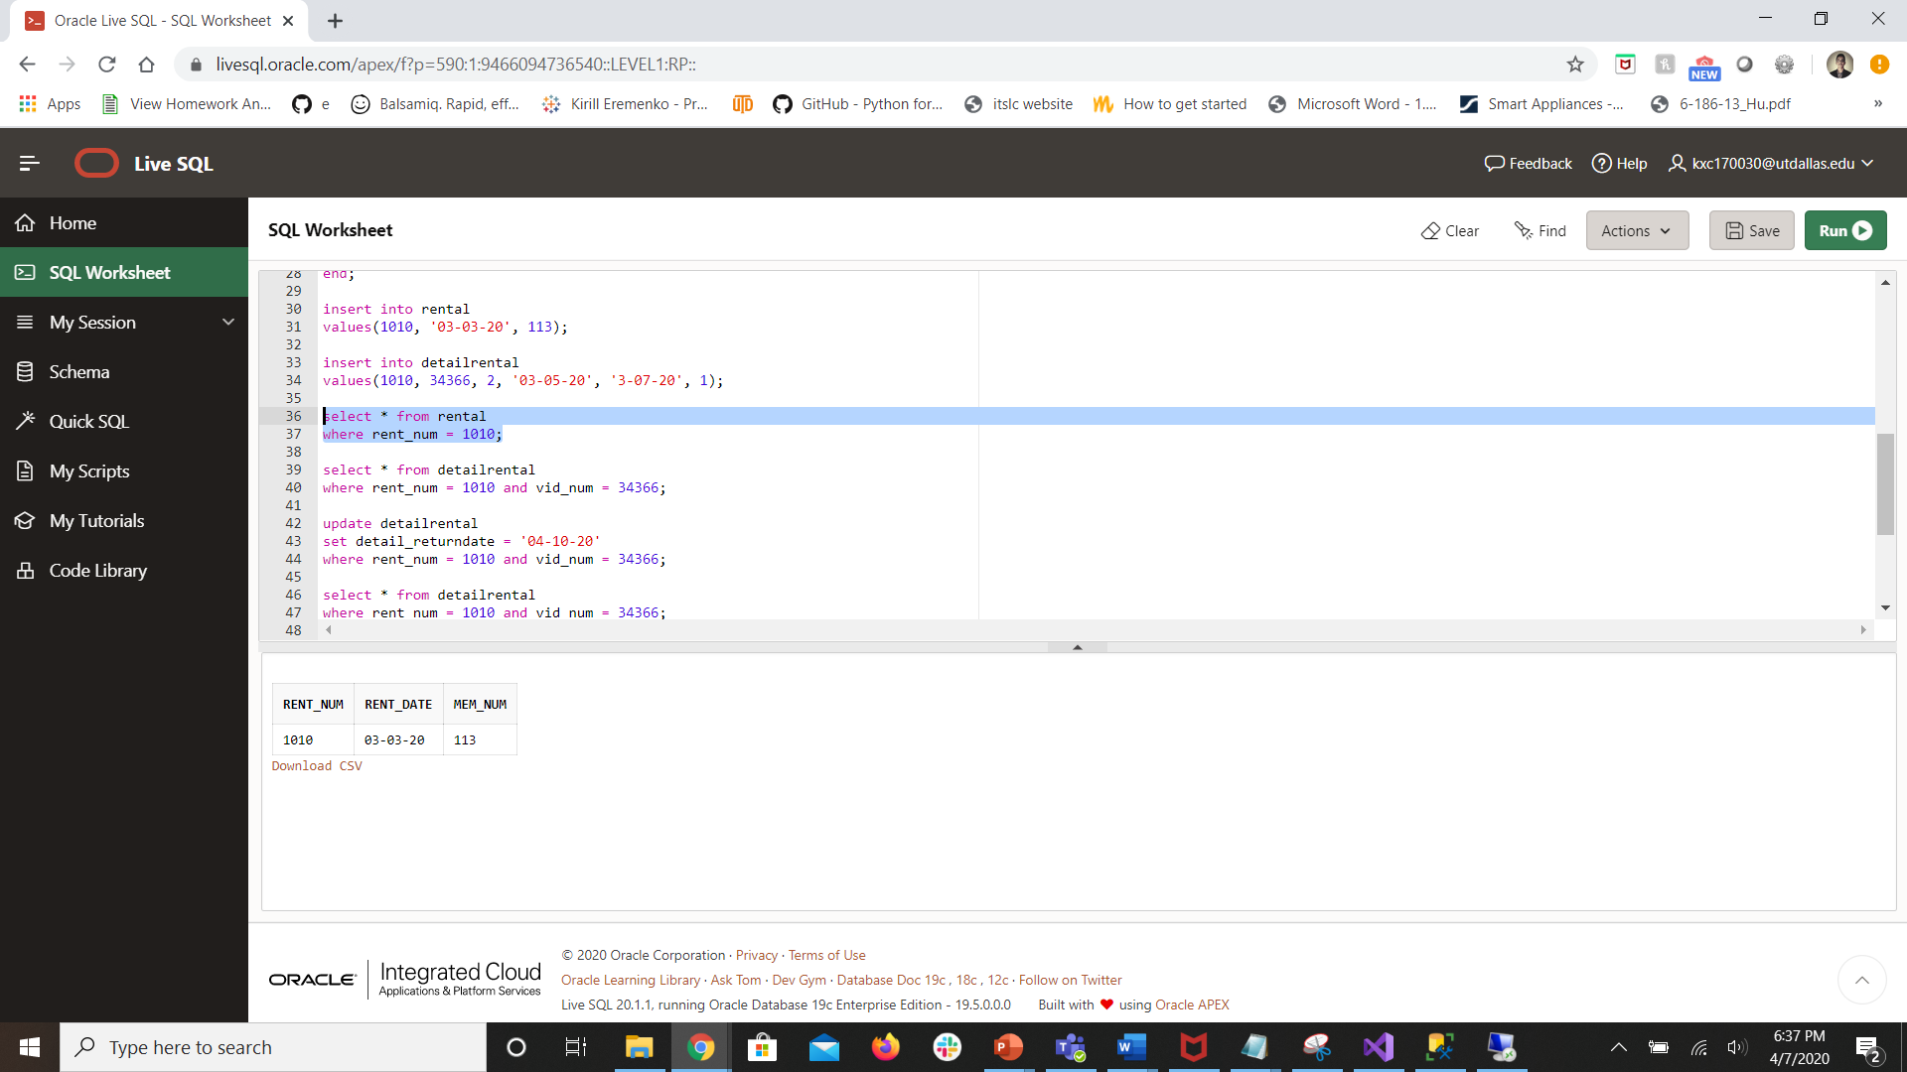

select * from detailrental
where rent_num = 1010 and vid_num = 34366;

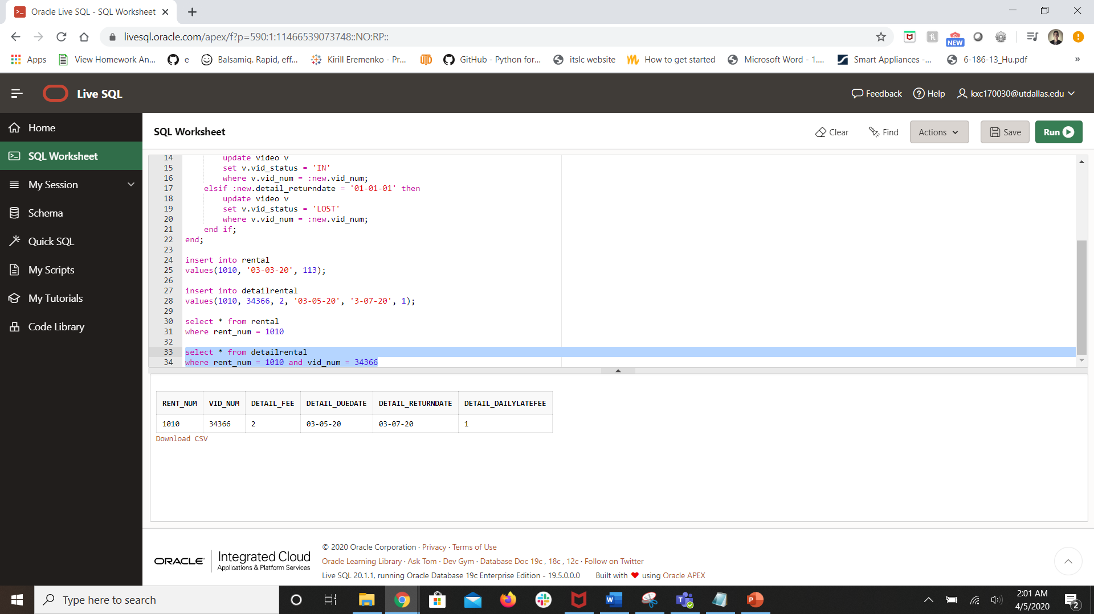

- To test the second condition – Update the detail_rental record you just added to set the returndate to a date in the future. Show the updated record after the update.

update detailrental
set detail_returndate = '04-10-20'
where rent_num = 1010 and vid_num = 34366;

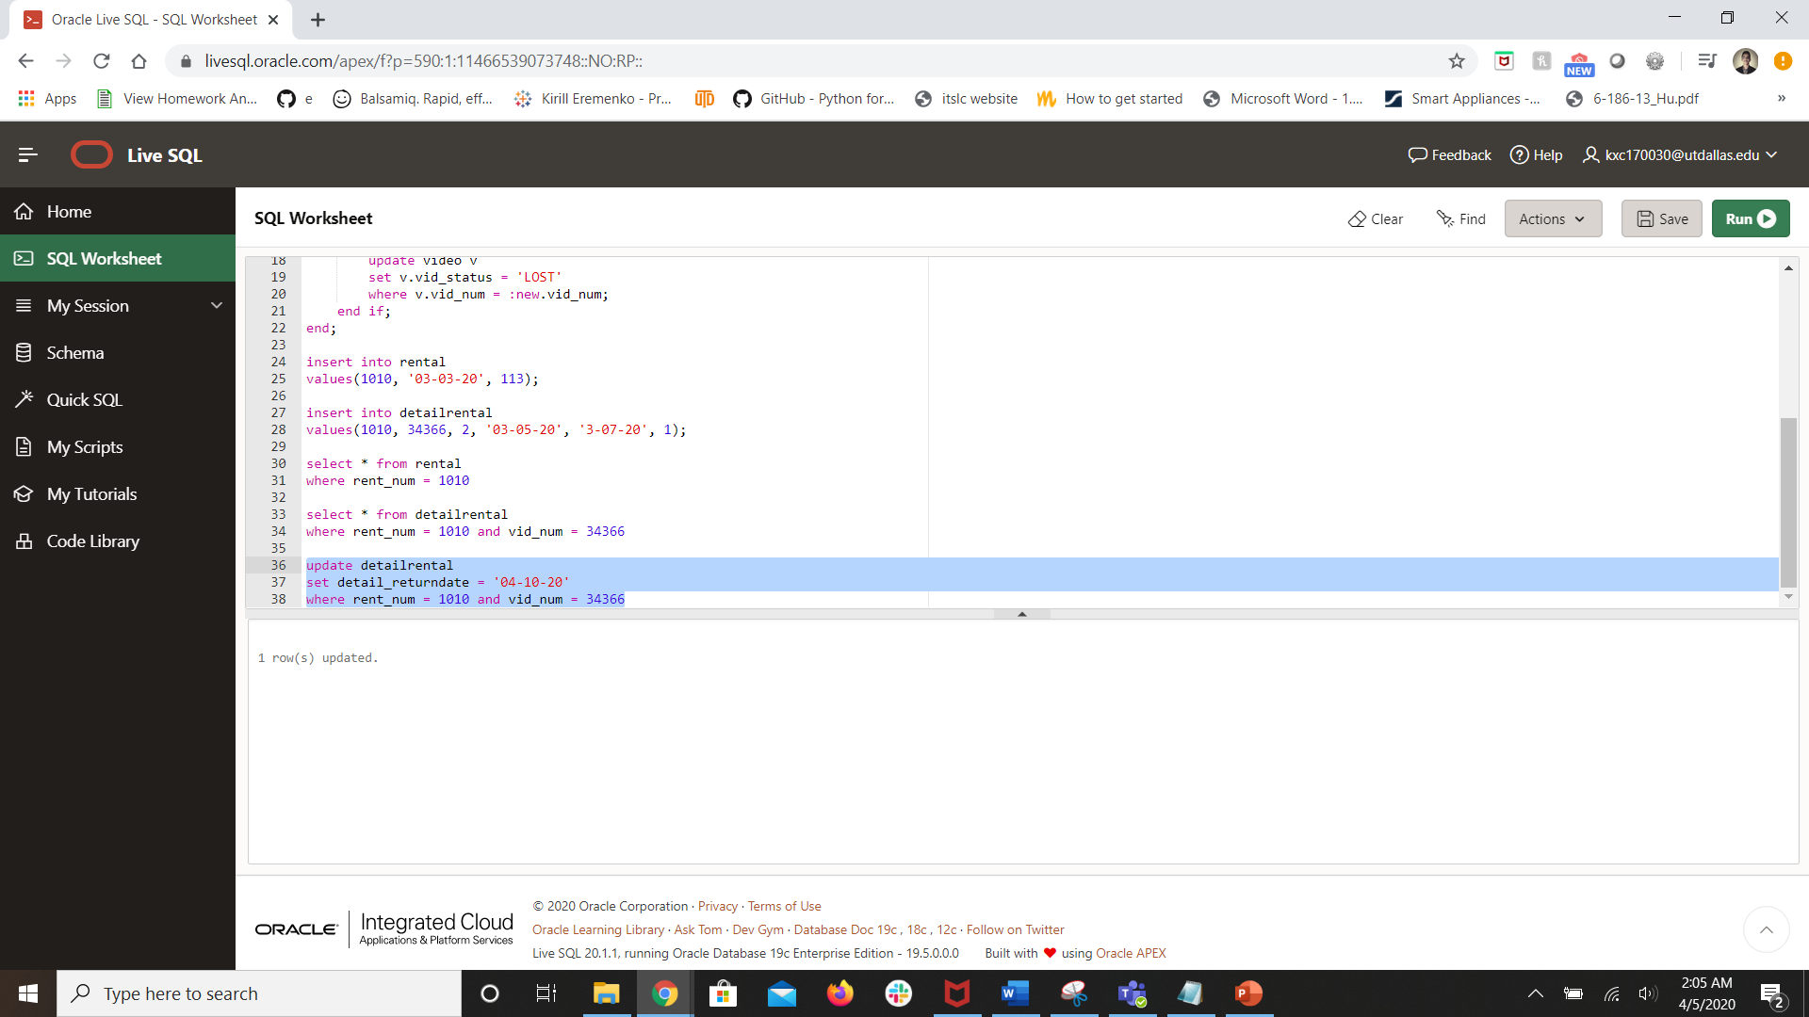

select * from detailrental
where rent_num = 1010 and vid_num = 34366;

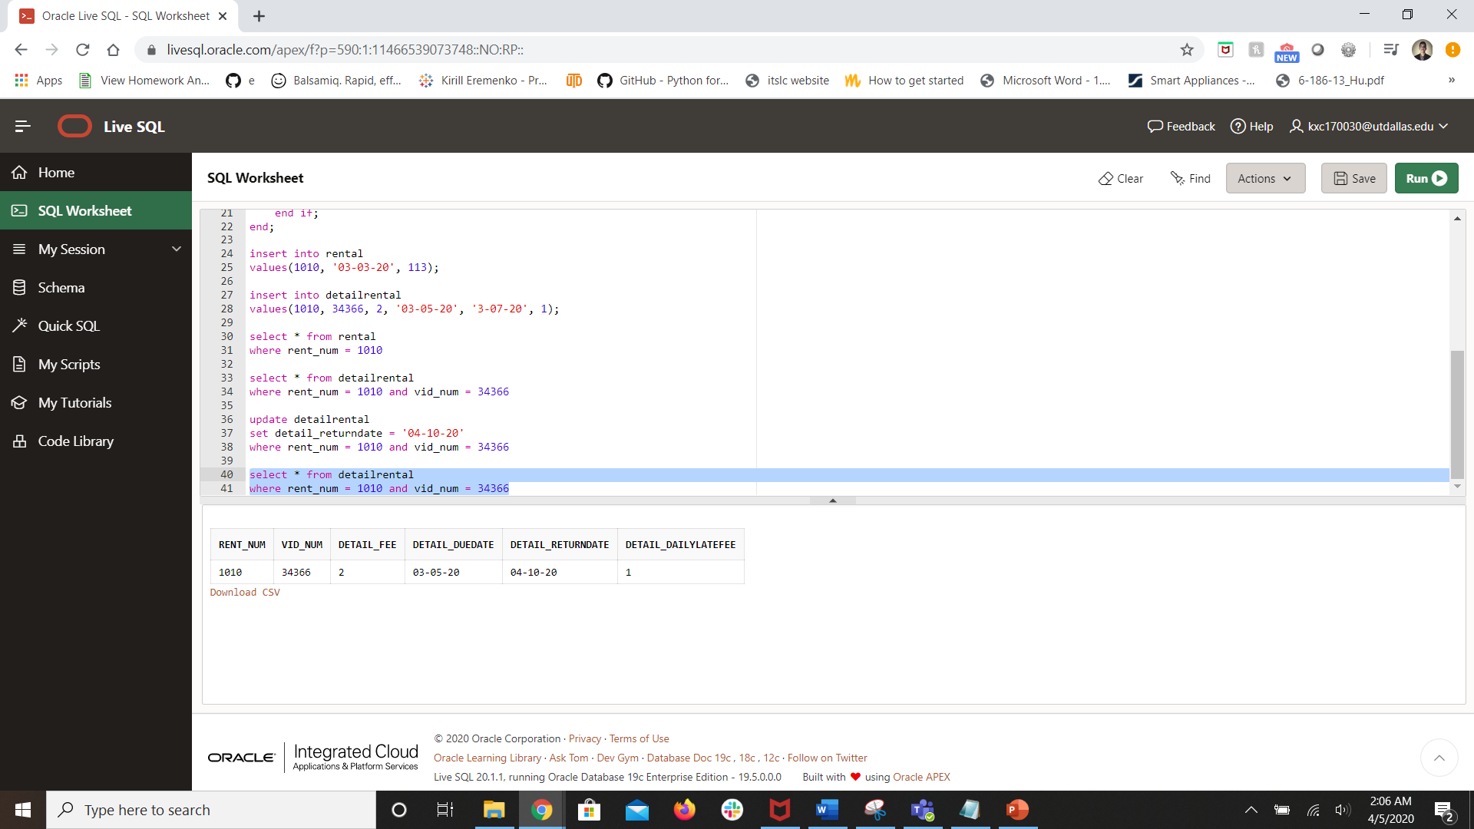

- To test the third condition – update the detail_renatal record to set the returndate to today. Show the updated record after the update.

update detailrental
set detail_returndate = sysdate
where rent_num = 1010 and vid_num = 34366;

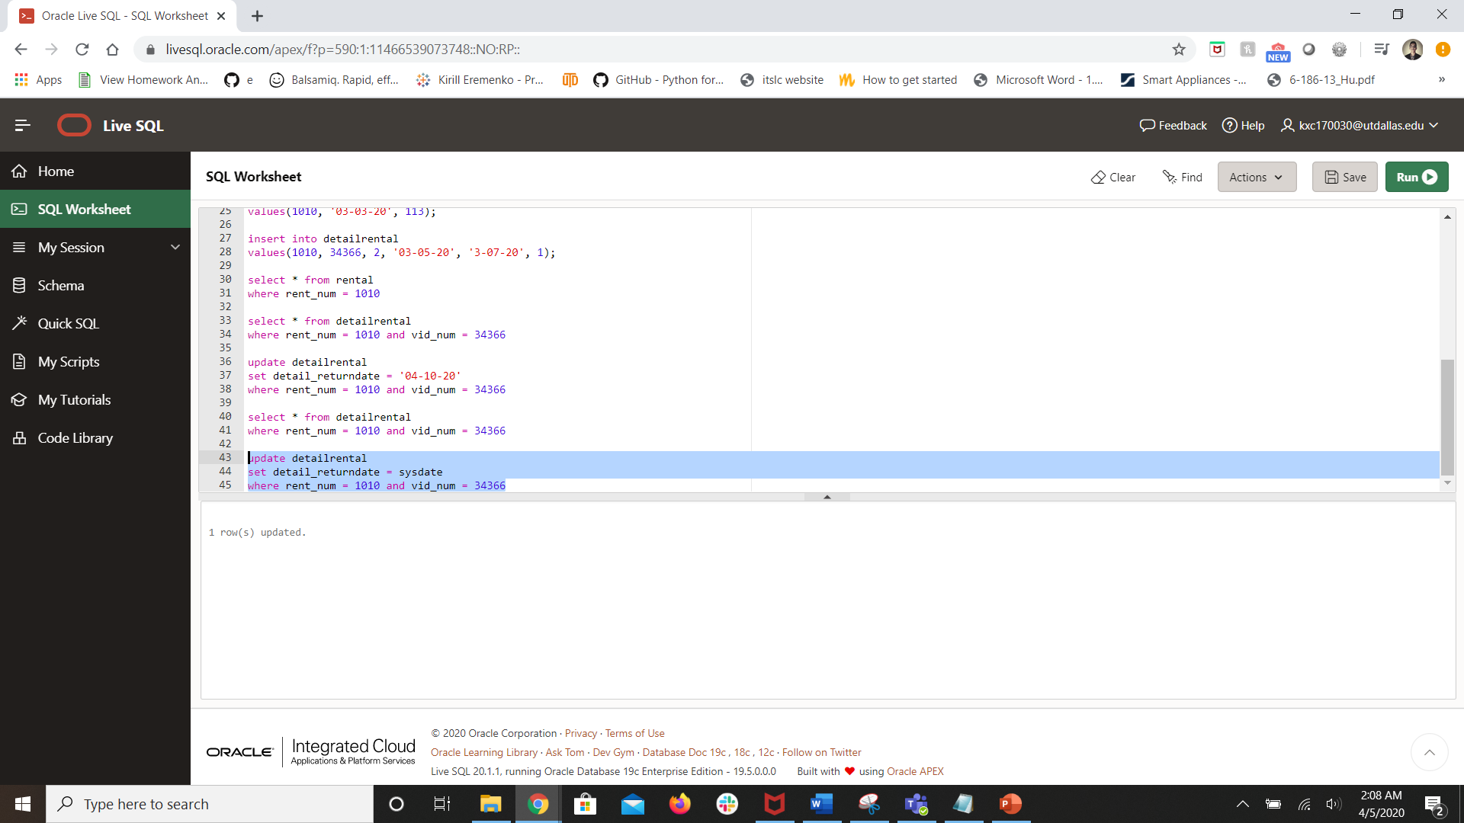

select * from detailrental
where rent_num = 1010 and vid_num = 34366;

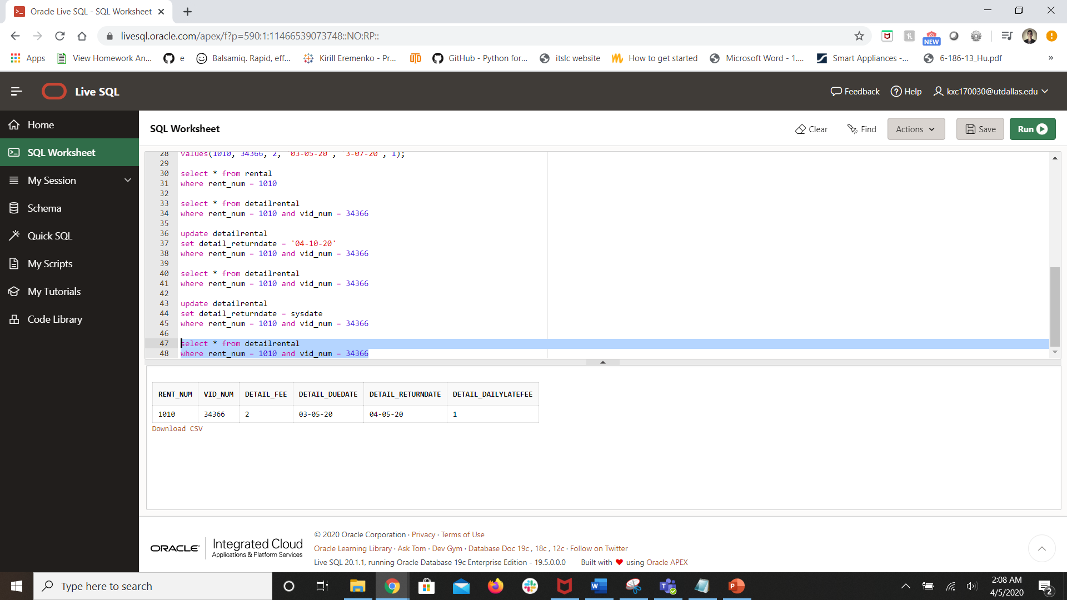

- To test the fourth condition – update the detail_record to set the returndate to 01/01/01 to set the movie as lost. Show the updated record after the update.

update detailrental
set detail_returndate = '01-01-01'
where rent_num = 1010 and vid_num = 34366;

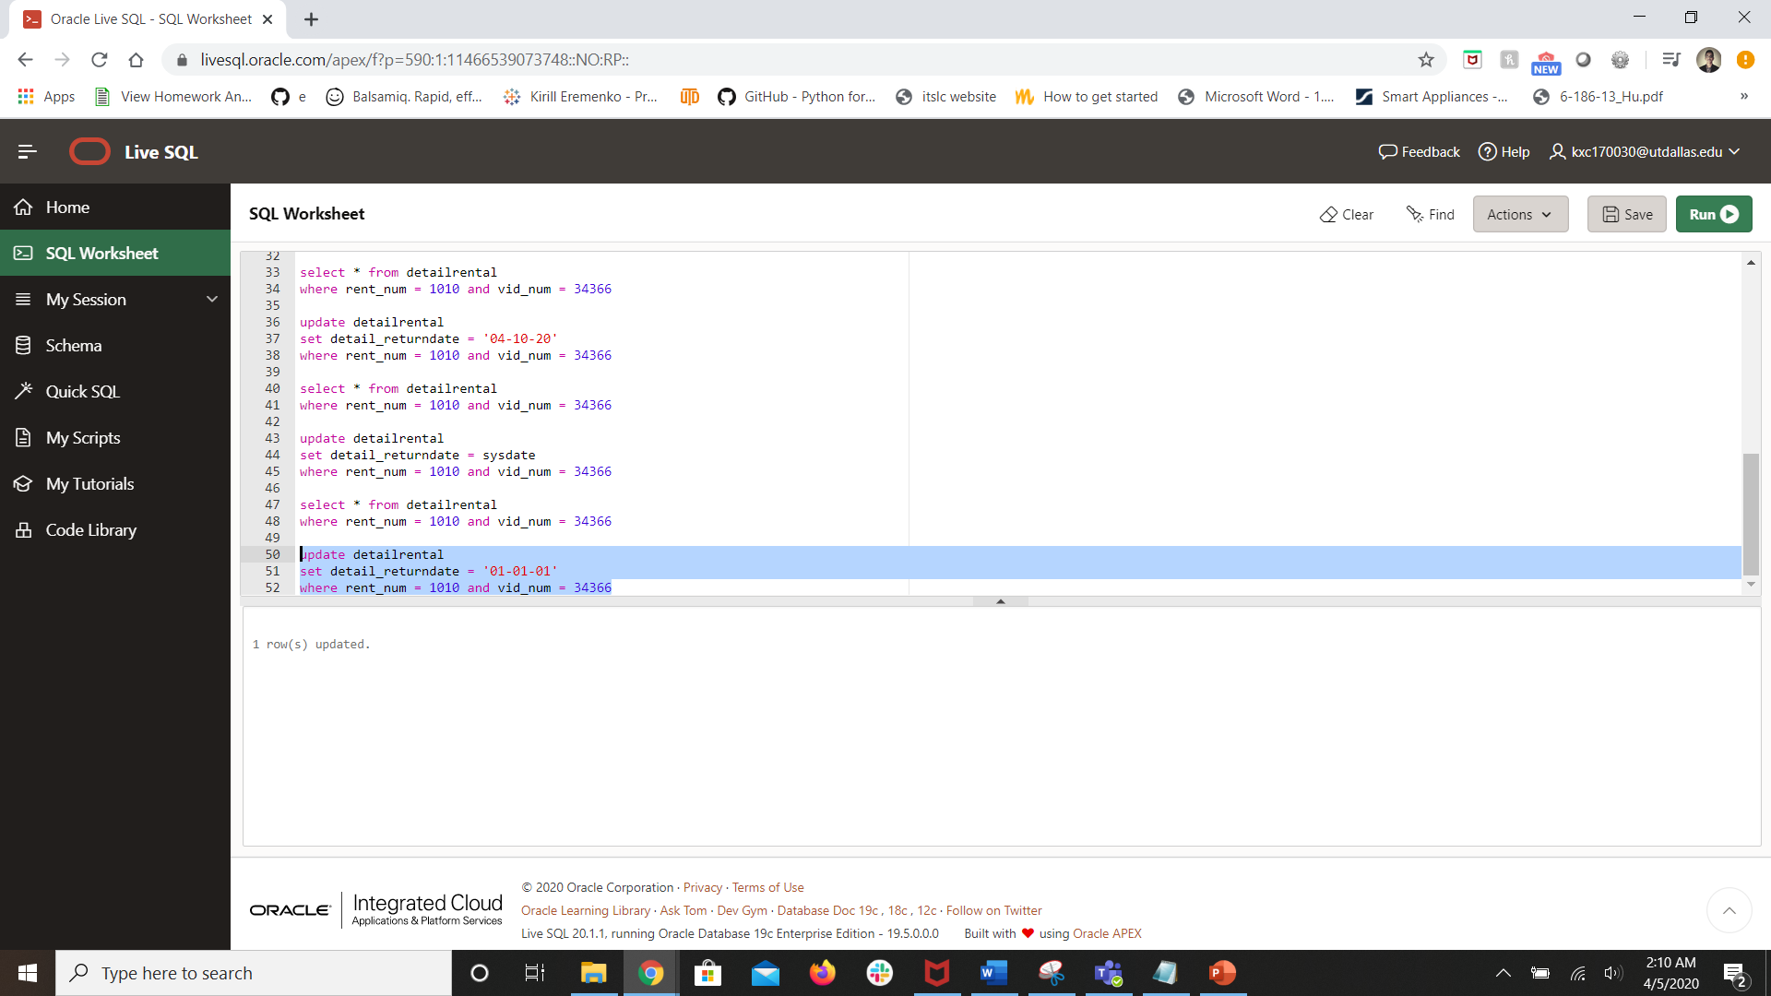

select * from detailrental
where rent_num = 1010 and vid_num = 34366;

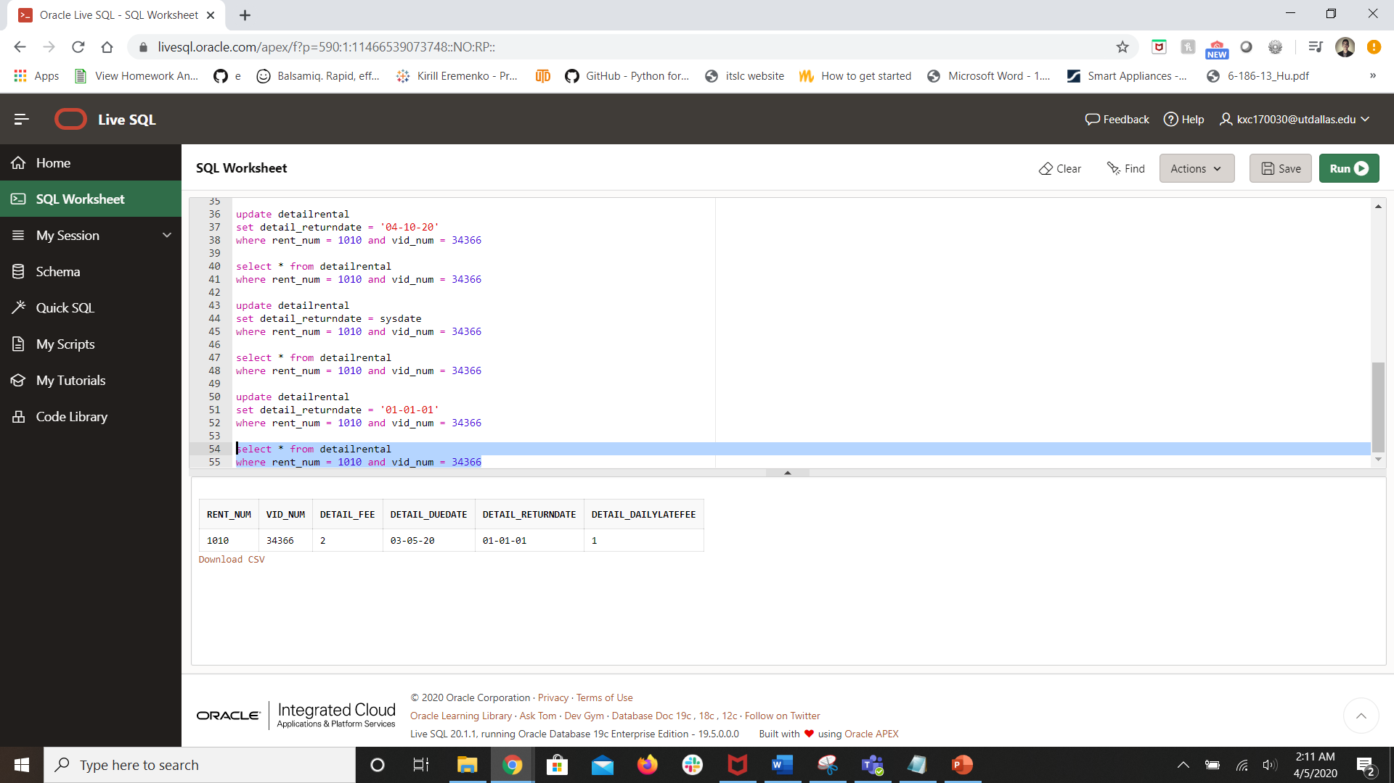

To show that the trigger has run, show the output from the following query:

select dr.rent_num, dr.vid_num, v.movie_num, m.movie_title, v.vid_status, dr.detail_duedate, dr.detail_returndate
from detailrental dr, video v, movie m
where dr.vid_num = v.vid_num and m.movie_num = v.movie_num

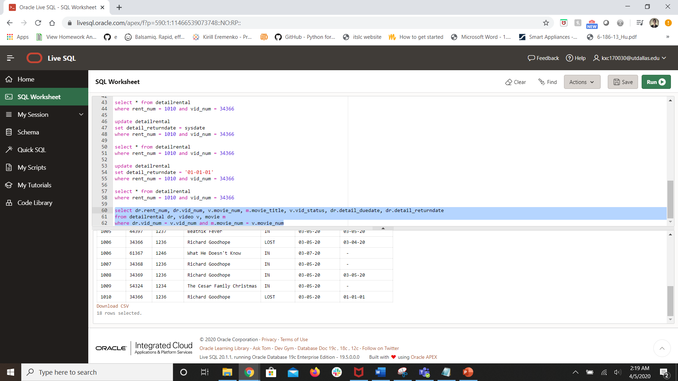

(10 pts for Trigger, 5 points for insert and update statements, 5 points for output)

- Create a stored procedure named sp_overduefees that will return the overdue fees for an overdue video. It will accept 2 parameters – the video number and the member id. I have provided you with the query that will return the overdue fees for the video number and member id.

SELECT (detail_returndate-detail_duedate), detail_dailylatefee, detail_fee,
to_char(((detail_returndate-detail_duedate)*detail_dailylatefee)+detail_fee, '$999.99'
FROM rental r, detailrental dr, video v, movie mv
WHERE r.rent_num = dr.rent_num AND
dr. vid_num = v.vid_num AND
mv.movie_num = v.movie_num AND
to_date(detail_returndate) > to_date(detail_duedate) AND
v.vid_num = #### AND
r.mem_num = ###;

--After you have created the stored procedure, test the procedure. To run the procedure, execute the following statement:

begin
sp_overduefees(110, 34367);
end;

When you run the procedure, you should receive the following output:
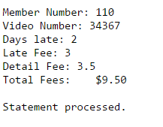

(10 pts for Stored Procedure, 5 points for output)

create or replace procedure sp_overduefees(member_id_param in number, vid_num_param in number)
is
w_days_late number;
w_late_fee number;
w_detail_fee number;
w_total_fees varchar2(50);
cursor return_overdue_fees_cursor is
SELECT (detail_returndate - detail_duedate), detail_dailylatefee, detail_fee,
to_char(((detail_returndate - detail_duedate) * detail_dailylatefee) + detail_fee, '$999.99')
FROM rental r, detailrental dr, video v, movie mv
WHERE r.rent_num = dr.rent_num AND
dr.vid_num = v.vid_num AND
mv.movie_num = v.movie_num AND
to_date(detail_returndate) > to_date(detail_duedate) AND
v.vid_num = vid_num_param AND
r.mem_num = member_id_param;
begin
dbms_output.put_line('Member Number: ' || member_id_param);
dbms_output.put_line('Video Number: ' || vid_num_param);
open return_overdue_fees_cursor;
loop
fetch return_overdue_fees_cursor into w_days_late, w_late_fee, w_detail_fee, w_total_fees;
exit when return_overdue_fees_cursor%notfound;
dbms_output.put_line('Days late: ' || w_days_late);
dbms_output.put_line('Late Fee: ' || w_late_fee);
dbms_output.put_line('Detail Fee: ' || w_detail_fee);
dbms_output.put_line('Total Fees: ' || w_total_fees);
end loop;
close return_overdue_fees_cursor;
end;
/

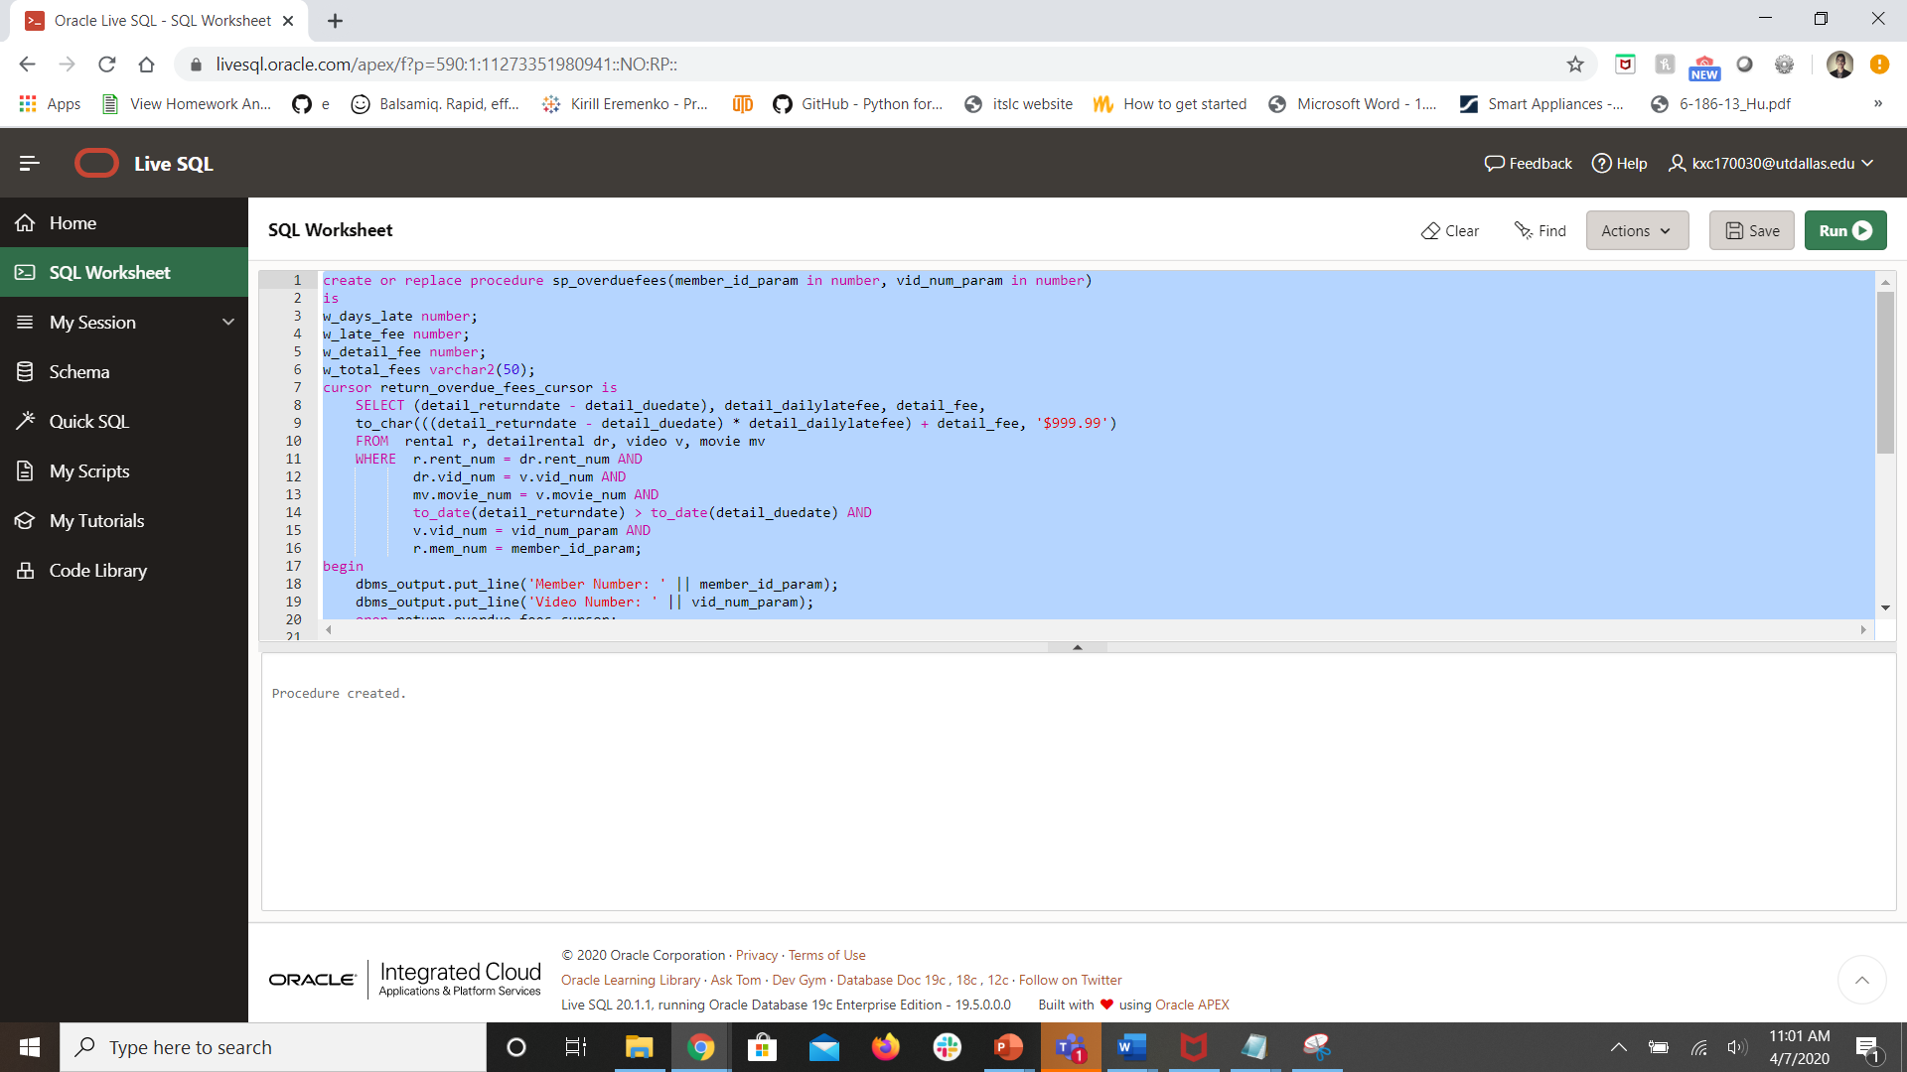

begin
sp_overduefees(110, 34367);
end;
/

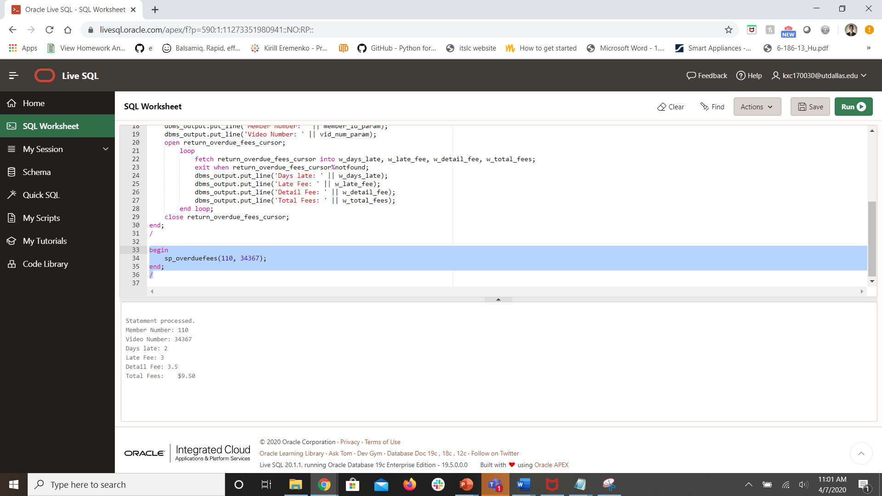

- Create a view that will show all the videos that are checked out. Call the view overdue_vw. (10 pts)

* I updated 2 records in detailrental to have a status of “OUT”*
update detailrental
set detail_returndate = '04-10-20'
where rent_num = 1010 and vid_num = 34366;

update detailrental
set detail_returndate = '04-10-20'
where rent_num = 1001 and vid_num = 34342;

select dr.rent_num, dr.vid_num, v.movie_num, m.movie_title, v.vid_status, dr.detail_duedate, dr.detail_returndate
from detailrental dr, video v, movie m
where dr.vid_num = v.vid_num and m.movie_num = v.movie_num;

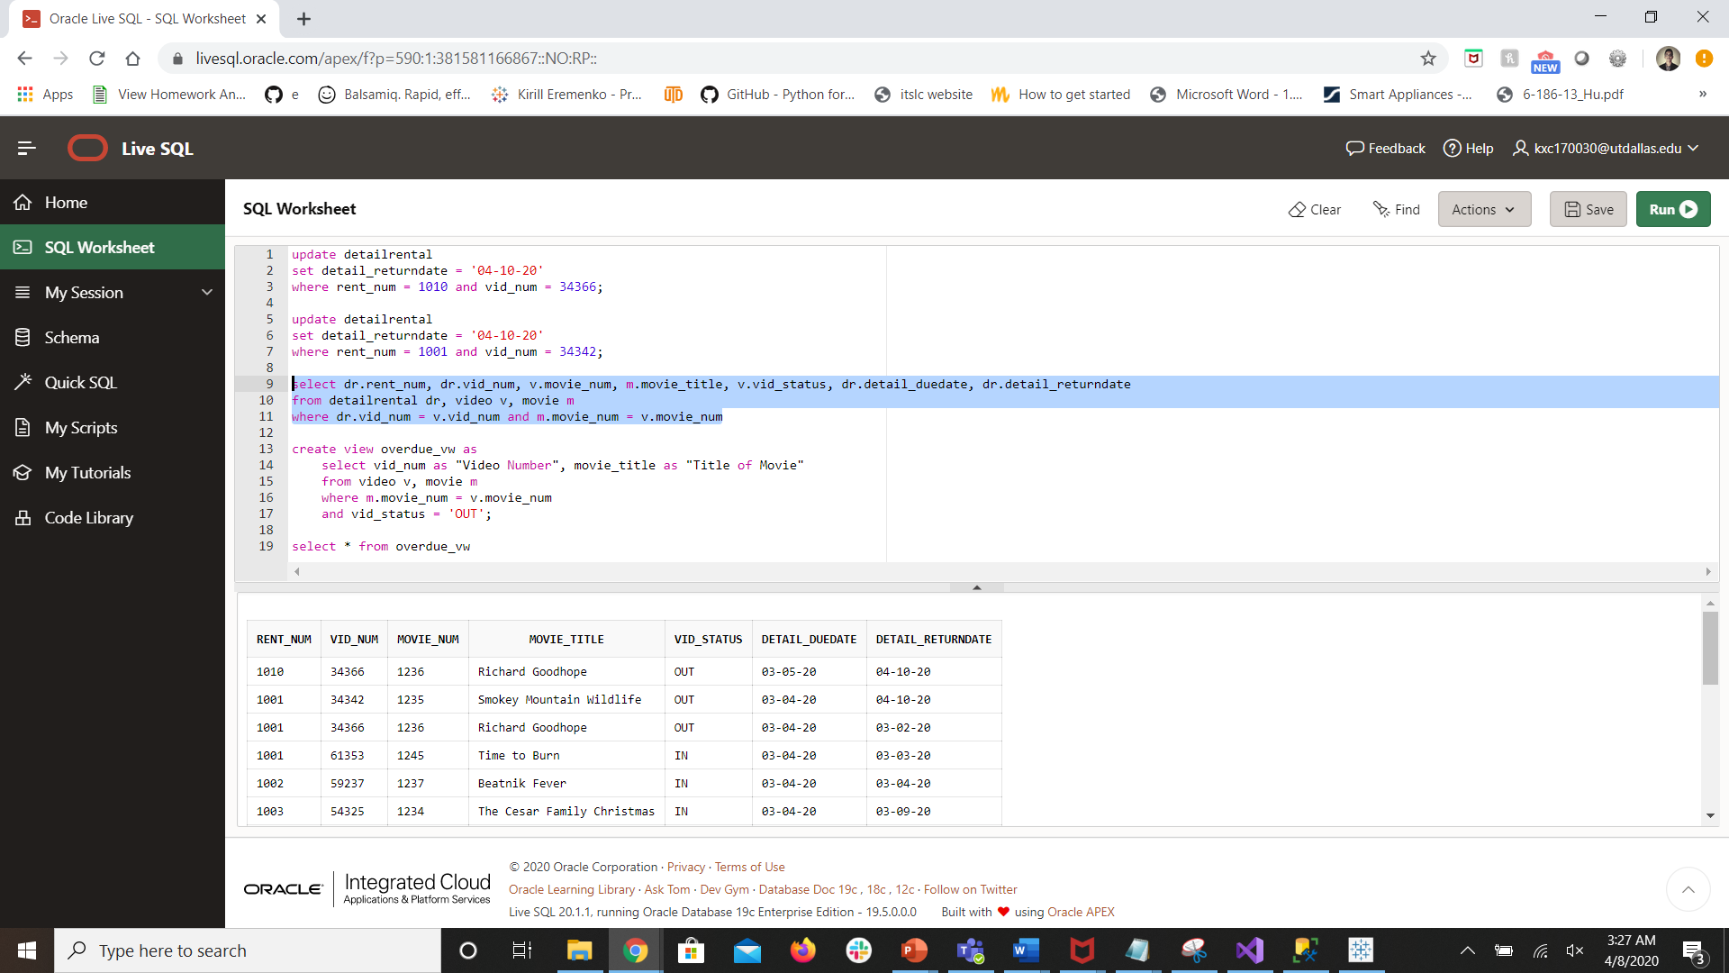

create view overdue_vw as
select vid_num as "Video Number", movie_title as "Title of Movie"
from video v, movie m
where m.movie_num = v.movie_num
and vid_status = 'OUT';

--After you have created the view, test the view by selecting all rows and columns from the view.

select * from overdue_vw;

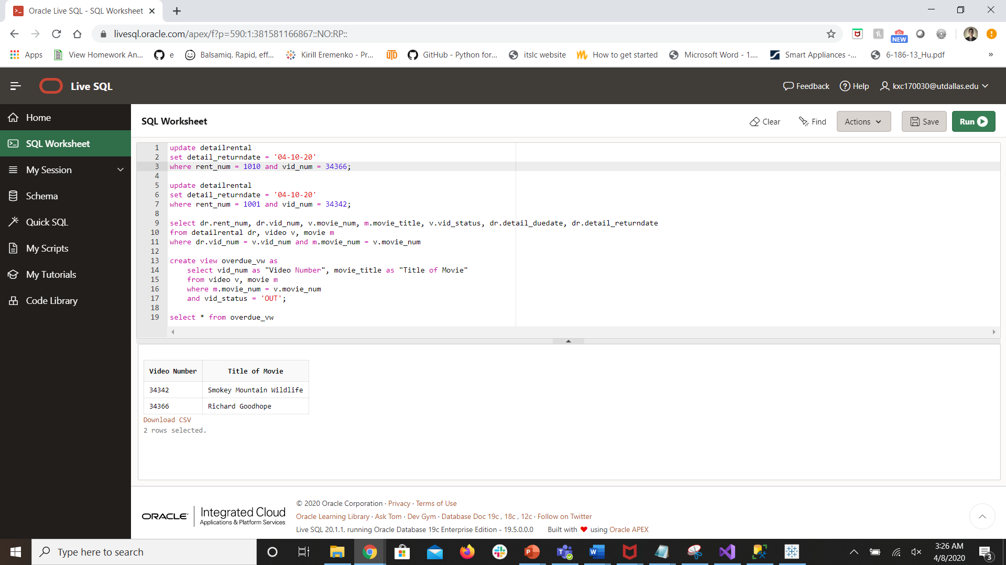

Extra Credit: 10 points

EC1: Create a stored procedure called sp_rental_members that accepts the member number as a parameter. This procedure should print all the videos that this member has checked out. The output should display the member number, the video number, title, rent date, due date, and return date. The output should look similar to the following – you may have different dates! You can be creative with your output.

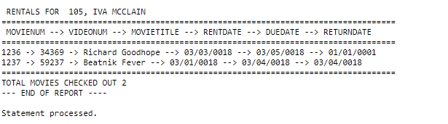

Hint: You will need a single row SELECT statement to display the member name and a cursor to display the rest.

create or replace procedure sp_rental_members(member_num_param in number)
as
w_mem_num membership.mem_num %type;
w_mem_name varchar2(50);
w_movie_num movie.movie_num %type;
w_video_num video.vid_num %type;
w_movie_title movie.movie_title %type;
w_rent_date rental.rent_date %type;
w_due_date detailrental.detail_duedate %type;
w_return_date detailrental.detail_returndate %type;
cursor w_checked_out_videos_cursor is
select m.movie_num, v.vid_num, movie_title, rent_date, detail_duedate, detail_returndate
from membership mem, movie m, video v, detailrental dr, rental r
where mem.mem_num = r.mem_num
and r.mem_num = member_num_param
and r.rent_num = dr.rent_num
and dr.vid_num = v.vid_num
and v.movie_num = m.movie_num;
begin
select mem_num into w_mem_num
from membership mem
where mem.mem_num = member_num_param;

select mem_fname ||' '|| mem_lname into w_mem_name
from membership mem
where mem.mem_num = member_num_param;

dbms_output.put_line('RENTALS FOR ' || w_mem_num ||', '|| w_mem_name);
dbms_output.put_line('============================================================================');
dbms_output.put_line('MOVIENUM --> VIDEONUM --> MOVIETITLE --> RENTDATE --> DUEDATE --> RETURNDATE');
dbms_output.put_line('============================================================================');

open w_checked_out_videos_cursor;
loop
fetch w_checked_out_videos_cursor into w_movie_num, w_video_num, w_movie_title, w_rent_date, w_due_date, w_return_date;
exit when w_checked_out_videos_cursor%notfound;
dbms_output.put_line(w_movie_num ||' -> '|| w_video_num ||' -> '|| w_movie_title ||' -> '|| w_rent_date ||' -> '|| w_due_date ||' -> '|| w_return_date);
end loop;

dbms_output.put_line('============================================================================');
dbms_output.put_line('TOTAL MOVIES CHECKED OUT ' || w_checked_out_videos_cursor %rowcount);
close w_checked_out_videos_cursor;
dbms_output.put_line('--- END OF REPORT ---');
end;
/

begin
sp_rental_members(105);
end;

